**TRIGGERS BASICS**

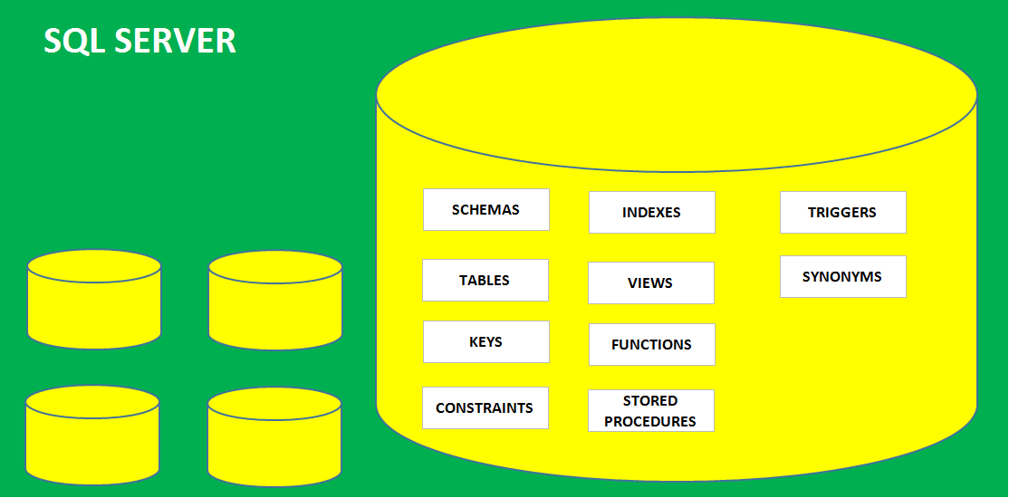

**TRIGGERS** ARE DATABASE OBJECTS USED TO **STORE** & **AUTO EXECUTE** ANY TSQL STATEMENT(S).

**Example**:

Whenever an employee joins the project respective PM should receive an email automatically.

Whenever we insert data into a table, same data should be auto replicated to another table.

**TYPES OF TRIGGERS:**

**1. DML TRIGGERS** : Applicable for auto execution in response to INSERT / UPDATE / DELETE

Types of DML Triggers:

a. **FOR / AFTER TRIGGER**: These Triggers are Auto executed IN ADDITION TO actual operation

b. **INSTEAD OF TRIGGER**: These Triggers are executed **in place of** actual operation

During the DML Trigger execution, TWO Memory tables are auto created. For Audits.

*"**INSERTED**" - Monitor the row(s) being inserted into the base Table (Camera @ Entry Gate)

*"**DELETED**" - Monitor the row(s) being removed from the base Table (Camera @ Exit Gate)

**2. DDL TRIGGERS** : Applicable for auto execution in response to CREATE / ALTER / DROP

**FOR TRIGGER** : Auto execute IN ADDITION to actual DDL operation

NO MEMORY TABLES ARE AUTO CREATED.

NO INSTEAD OF TYPE APPLICABLE FOR DDL TRIGGERS.

**DEVELOPERS** : CREATE OR CODE THE TRIGGERS, TEST THEM. PROGRAMMING.

**SQL ADMINS, DATA ENGINEERS** : MANAGE THE TRIGGERS [DISABLING & ENABLING, SECURING].

**DATA ANALYSTS** : NO SPECIFIC JOB ROLE PERTAINING TO THESE TRIGGERS.

**Syntax For Trigger Creation:**

CREATE TRIGGER <<triggername>>

ON <tablename>

FOR | INSTEAD OF

<<dml or ddl operation>>

AS

BEGIN

statement 1

statement 2

statement 3

.......

END

CREATE DATABASE DBTRIGERTEST

USE DBTRIGERTEST

create table Reservation

(

Aircraft_Code varchar(10),

No_of_Seats int,

Class_Code varchar(10)

)

-- ITEM #1: HOW TO DEFINE A TRIGGER ON THE TABLE?

-- REQUIREMENT: WHENEVER WE PERFORM DML OPERATION ON A TABLE, WE NEED TO PRINT ONE CONFIRMATION MESSAGE.

CREATE TRIGGER trgAddlOpn ON Reservation

FOR INSERT, UPDATE, DELETE -- IN ADDITION TO

AS

PRINT 'GIVEN OPERATION IS SUCCESSFUL.'

-- ITEM #2: HOW TO TEST ABOVE TRIGGER?

-- TRIGGERS ARE AUTO EXECUTED IN RESPONSE TO DML, DDL EVENTS

INSERT INTO Reservation VALUES ('EMI101', 11, 'ECO') -- TRIGGER IS EXECUTED

SELECT * FROM Reservation1

DELETE FROM Reservation WHERE No_of_Seats = 11 -- TRIGGER IS EXECUTED

SELECT * FROM Reservation1

-- ITEM #3: HOW TO MAKE YOUR TABLE READONLY?

CREATE TRIGGER TrigAltOperations

ON Reservation1

INSTEAD OF INSERT, UPDATE, DELETE

AS

PRINT 'TABLE IS READ ONLY.'

-- ITEM #4: HOW TO TEST / EXECUTE ABOVE TRIGGER?

DELETE FROM Reservation1

UPDATE Reservation1 SET No_of_Seats = 10

-- ITEM #5: HOW TO DISABLE A TRIGGER?

DISABLE TRIGGER TrigAltOperations ON Reservation1

DELETE FROM Reservation1

-- ITEM #6: HOW TO ENABLE A TRIGGER?

ENABLE TRIGGER TrigAltOperations ON Reservation1

DELETE FROM Reservation1

-- ITEM #7: HOW TO REPORT LIST OF TRIGGERS IN THE DATABASE?

SELECT * FROM SYS.TRIGGERS

-- ITEM #8: HOW TO GET DEFINITION OF A TRIGGER?

EXEC SP_HELPTEXT 'TrigAltOperations'

EXEC SP_HELP 'Reservation1'

-- ITEM #9: HOW TO DROP A TRIGGER?

DROP TRIGGER trigAltOps